Parent invite
October 29, 6-7:30

Presentation on standards based report cards followed by a Q & A

 | 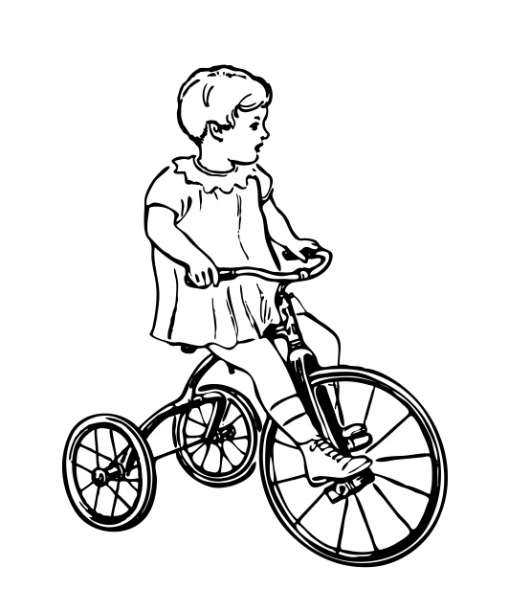 | 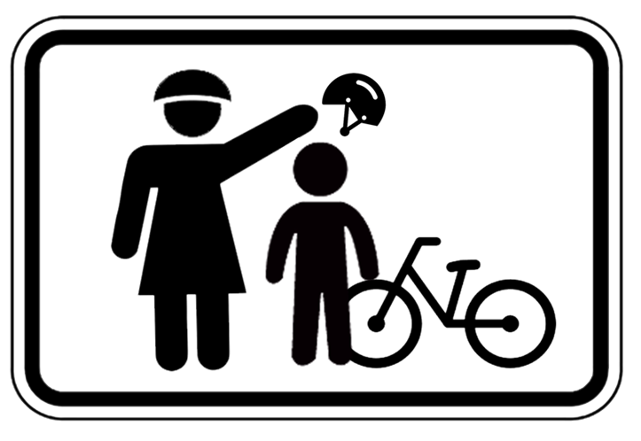 | 

1 2 3 4

Dinner provided
Have you ever heard of Standards Based Grading or 1, 2, 3, 4 as a grading scale? As many of you know, Twin Bridges K-2 has used a Standards Based Grading system and 3rd and 4th grade are implementing this system this year. There are many parents who regularly ask what the 1, 2, 3, 4 means as it relates to their child’s learning. We hope to provide you information about Standards Based Grading and how we will use it to assess your child’s learning, give feedback as it relates to your child’s progress, and what would meet a proficient level of understanding.

